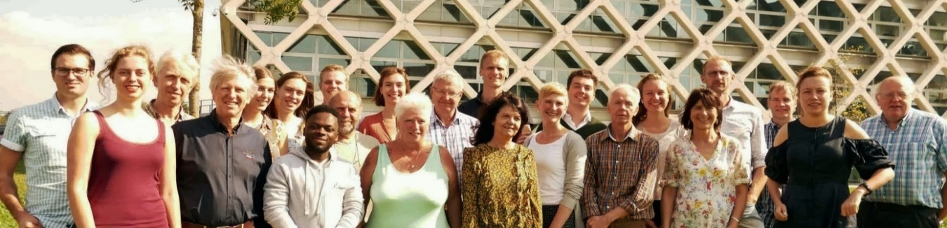
WUR Council 2018-2019
Annual report WUR Council 2019
This report is about the main activities of the WUR Council in 2019; what we have tried to accomplish for WUR, its students and employees, in the previous year. If you don’t know what the WUR Council is or does, you can find some answers in the list of FAQ’s. You can also find the WUR Council on the internet.

Quality Agreements
The Quality Agreements must ensure the money from abolishing the basic student scholarship is used to improve the quality of education for all students. The WUR Council asked to invest in small scale education, room for lecturers to develop themselves and their courses, and attention for personal development for students.

Misconduct Complaints
Because also within the WUR community things can go awfully wrong between people, there is a regulation for complaints about undesirable social behaviour. The WUR Council emphasized that both parties, be it as complainant or defendant, must be made well aware of their rights. The EB agreed to give extra attention to this.

Workplace Shortages
WUR is bursting at the seams. In the 2019 budget the WUR Council asked for a maximal effort towards solving housing problems, which led to much building activity on campus. The EB also promised to reassess the Campus Plan, including an update of the vision upon the "New Way of Working", dating from 2013. To be continued ...

Third Eductional Building
The number of students at Wageningen University is growing very fast. To have enough lecture rooms for all these students, a third eductional building is built, next to Forum and Orion. The WUR Council does not know the name of the new building, but has been discussing the building plans, and how they could be improved.

Osiris
OSIRIS will become the registration system for student data. Earlier attempts for introducing a new system have failed miserably. The OSIRIS system already works at many other universities. The WUR Council has sufficient confidence it will also work for us, but emphasizes to make sure everyone involved is well informed.

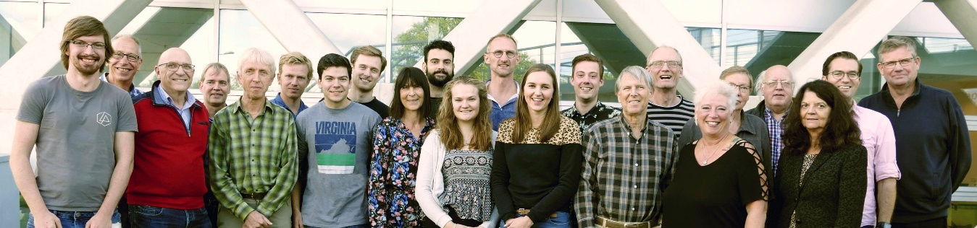
WUR Council 2019-2020
Ground Coupled Heat Exchanger
WUR wants to invest in a ground couped heat exchange system for all buildings on campus. This will help heating without using natural gas, and make cooling in summer easier. The WUR Council supports the proposal, provided urgent heat problems are solved with priority. This is possible, according to EB, if economically justified.

Medezeggenschap 2.0
The Dutch word Medezeggenschap means much more than its English equivalent participation, at least the Dutch like to believe so. The WUR Council joined with management in an effort to reinvent Medezeggenschap, to make clear that participation is fun, useful, good for your career, and did we say fun?

Dialogue Centre
The Dialogue Centre will be used as auditorium, conference and debate centre. The WUR Council hopes the building will lift pressure of educational buildings, such as Orion, which are currently used for events and advised to safeguard this. The council also proposed to use the building to present topical themes that WUR is involved in.

Education Career Path
The Education Career Path (ECP) is an instrument to acknowledge achievements in academic teaching. The council was positive about the proposal, but advised to make available a clear overview of the ECP procedure to serve as guideline for all parties involved and to take record of agreements between chair groups and employees.

Wageningen University Budget 2020
The WUR Council discussed the framework letter and budget 2020 with the EB and addressed several concerns, including the lack of proper office and study places; facilities should grow according with organisational growth. We further discussed work pressure and stress, which affects employees, PhD candidates and students.

News WUR Council
In 2019 we have once again restyled our newsletter, and increased its frequency. Before every consultation meeting there is a newsletter, allowing everybody to give input. If you want to keep up to date, don’t forget to register. We also have a poll on the intranet to ask the opinion of the employees about a dilemma.

WUR Council FAQs

For the answer to a question, click the triangle to the left of it. Click again to close.

What is the WUR Council?
The WUR Council is part of the central participation structure of Wageningen University & Research (WUR). It combines the Central Works Council (COR in Dutch), with representatives of employees, and the Student Staff Council (SSC), with representatives of WU employees and students. In total the WUR Council has about 25-30 members.

What does the WUR Council do?
The WUR Council discusses with the Executive Board (EB) the general policies of WUR. For certain decisions the EB first has to ask the WUR Council (formally COR or SSC) for advice or approval. If the advice is negative or there is no approval, the EB will renegotiate the decision with the WUR Council. The annual report highlights some of the dossiers of 2019. You can also read the report over 2018 and 2015 – 2017.

What kind of topics are involved?
The decisions apply to policies that affect many employees at WUR, or both employees and students. Examples are travel policies, privacy matters, the general budget, campus development, education structure, employment policies, and big software investments. But also the strategic plan, stipulating the general goals our organisation strives for, and the chair plan, stating what in general we teach our students, are discussed with the WUR Council.

What does the WUR Council do for me?
That depends on what your position is. For students, many issues are discussed with the Student Council (SC). Only when also teachers are involved, the SSC comes into play. For employees many things are discussed with the local works councils of the different Sciences Groups, the WUR Council deals with the broader topics. Always the participation structure tries to make sure WUR is a good place to work and study for everybody.

How do I know what issues are being handled?
The WUR Council has a newsletter that mentions what topics are on the agenda, and what results have been achieved. You can register for the newsletter. It contains a link to the actual agenda of the WUR Council meetings. In the agenda you can find references to letters and memos that give you all the details. Some documents are confidential, but many are public and anybody from WUR can read these. Not that you can always understand what they mean though …

Can I work with the WUR Council?
Yes, you can. Everybody can at any time become member of one of the committees of the WUR Council. Each committee has its specific field; Finance, Education, Housing, Communication, ... .You can become an actual member of the WUR Council only by being elected, either for the SC (if you are a student), for one of the local councils (if you are an employee), or for the SSC (if you are a WU employee or a PhD candidate). Elections are held annually for students and PhD candidates (in May), and every three years for employees (the next ones are in May 2020).

How can I reach the WUR Council?
The simplest way is to write a mail to wur.council@wur.nl, the general mail address. Someone will then get in touch with you and help you further. You can also go to the teamsite of the WUR Council and try and find your way, but it’s easy to get lost. We also have a group on the intranet. Of course if you know somebody who is in the WUR Council, often the quickest way is to just call them.

