Natural Nano-emulsions for Waterproofing and Softening Mycelium Textiles

Final wildcard project report

Renko de Vries (WU-PPC)

Costas Nikiforidis (WU-BCT)

Ben van den Broek (WFBR)

22 December 2022

This project has been funded by the investment theme Transformative Bioeconomies: Towards a materials transition that phases out fossil feedstock

# 1. Introducing the project

# Innovative idea and objective

Biomass, such as plants and microorganisms, can replace fossil feedstocks for the production of textiles and films. One of the problems is turning biomass into a flexible and water-repellent material. The idea is to use nano-emulsions as water repellent agents to be homogenously distributed throughout the biomass. Nano-emulsions are a heterogeneous dispersion of two immiscible liquids (oil in water or water in oil). The droplets of these emulsions will be coated with water-soluble polysaccharides that will have sorption with the biomass. The objective is to redesign the physical interactions between the biomass and the nano-emulsion droplets. The aim is that after incorporation of the nano-emulsion and subsequently drying the water-repellent behavior of the material will be increased.

# Relevance to the materials transition in textiles and/or building materials?

Most biomass is hydrophilic and becomes brittle and glassy in the absence of water, its natural plasticizer. It is relatively easy to replace the water with a hydrophilic plasticizer such as glycerol, but that leads to rather hydrophilic materials with poor water resistance. It is very hard to replace the water by a hydrophobic plasticizer. To use of abundant biopolymers such as chitin, cellulose or amply available proteins such as zein directly for making bioplastics, films, fibres or non-woven textiles is therefore limited. The problem of turning intrinsically hydrophilic biomass into water resistant and flexible materials in a sustainable manner is essentially unsolved, and this has significantly held back the performance of many biobased materials as compared to the equivalent fossil-feedstock-based materials. In this project we studied the possibilities to tune the physical interactions between the nano-emulsion droplets and the biomass. In order to achieve nano-emulsion formulations that naturally and homogeneously will spread throughout the biomass and remain stable also during and after drying and results in improved properties of such as flexibility and increased water repellent properties.

# What did you do?

The project is divided into three main subjects.

* Definition of water-soluble polysaccharides and the biomass to be used. Development of the sorption screening assay between biomass and water-soluble polysaccharides.
* Preparation of nano-emulsions and coating of the droplets with the most promising water-soluble polysaccharide and also proteins.
* Investigation of the formation of films made of nano-droplets and polysaccharides or proteins.
* Measurement of the nano-emulsion droplets into the biomass.

The focus was on the development of the sorption screening assay.

# Main result, achievement and highlight

Mycelium was chosen as a biomass source and as polysaccharides arabinogalactan and pectin. Setting up the sorption procedure had some drawbacks as coupling of the fluorophore did not result in the desired coupling, although different coupling methods were used. Using a different characterization method we noticed that the pH is important for the sorption of the water-soluble polysaccharides to the biomass source. For the measurements of the nano-emulsion into the biomass, we have acquainted ourselves with the use of confocal laser scanning microscopy (CLSM). The insight that we obtained is that the conditions are important to obtain good sorption of the polysaccharides.

# Key message

To make biomass sources such as mycelium more flexible and water repellant nano-emulsions coated with water-soluble polysaccharides can have potential.

# Visual abstract



Figure 1: Project approach.

a ) Partition assay/screening to determine sorption of water-soluble polysaccharides into biomass as a function of polysaccharide type and sorption conditions (time, pH, salt,...)

b) Coating of rapeseed natural nano-emulsions (oil bodies) with water soluble polysaccharides selected from screening

c) Polysaccharide coating facilitates sorption of nano-emulsion droplets into biomass and ensures homogeneous distribution.

# 2. Questions about ‘readiness’ and possible follow-up

## Where you started

We had an idea and had to start from scratch. The only method which was established before the start of the project was the formation of nano-emulsions.

## Where are you now

The first step, coupling of a fluorophore, was time-consuming due to the delivery time of the fluorophore and the method that did not work under the conditions used. Now we have proven, in another way, that water-soluble polysaccharides can bind to a biomass under certain conditions. The next step should be the production of coated nano-emulsion droplets followed by measurements if this can be homogenously distributed over the biomass itself.

## Potential and next steps

We think that the potential of our approach can be very high if successful. It has the potential to be used in other types of textiles and materials to improve its properties. The logical next steps are to find funding to elongate the feasibility study.

## Innovation readiness

The readiness is now 1-2 according to Table 2. The feasibility study needs to be finished in order to judge if this approach is working. Thus lab testing is needed before it can be piloted in society.

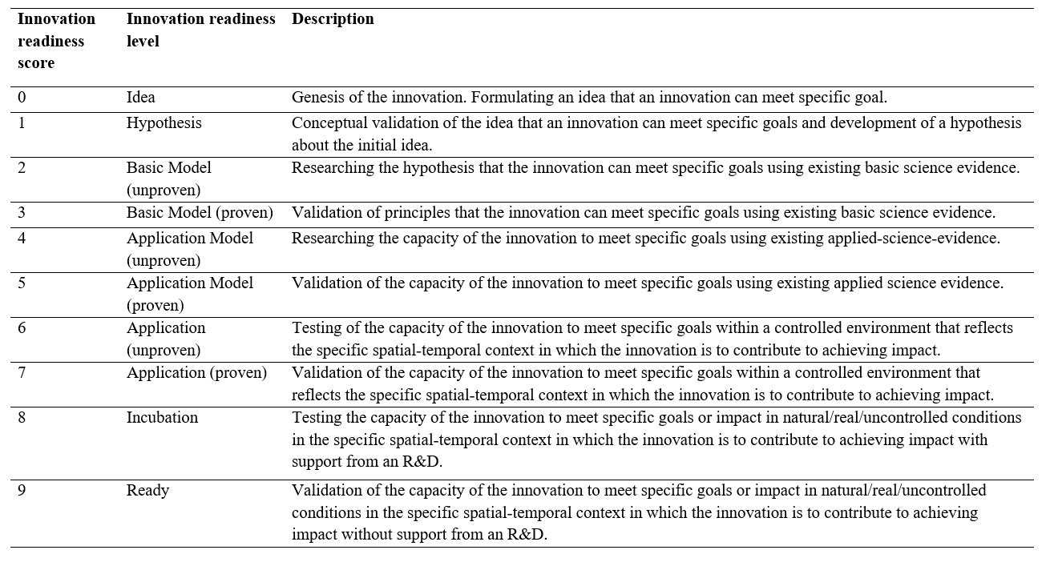

Table 2: Innovation readiness levels as distinguished by Sartas et al, 2020.

# 3. Learning Journey

1. Did your Wildcard project involve new collaboration with disciplines or people?

Yes with Renko de Vries (WU-PPC) and Costas Nikiforidis (WU-BCT). I did not work before with Renko and Costas. Nice is to get more insight into different working areas and to see how your work can be integrated.

2. If applicable, did the new collaboration alter your original thinking about the topic? Did it change research directions or courses of action? If so, briefly characterize how.

Yes, in the beginning, we had too much focus at already the end product. Now it is noticed that the basic steps were more time demanding than anticipated.

3. Did interactions during community days and/or meetings organized by the investment theme alter your original thinking about the topic? Did such interactions change research directions or courses of action? If so, briefly characterize how.

Yes, people were very enthusiastic about the topic and give some ideas.

4. Did you meet any challenges during the implementation of your wildcard project? If so, what kind of challenges where these?

One of the challenges was how the money was transferred to our group. This was not clear communicated.

5. If applicable, how were these challenges eventually addressed? Did activities organized by the investment theme contribute to overcoming challenges? If so, briefly indicate how.

I heard from a person from other projects how this was arranged.

6. Has your involvement in the investment theme resulted in any new initiatives or spin-offs that would probably not have emerged if you had not participated? If so, briefly indicate how these new initiatives came about.

I have been invited by another group to participate in their project on using seaweed as construction material.

This project triggered discussions with other industrial partners on potential research activities on this scientific area

# 4. Additional project specific deliverables

## Additional deliverables proposed when submitting the Wildcard project

1. For a range of natural stabilizers (lipids, proteins, biobased surfactants) we will explore the affinity of emulsion droplets for (wet) mycelium biomass in partitioning experiments (what fraction of emulsion droplets associates with the biomass and what fraction not). We expect electrostatic interactions will be among the most tuneable interactions, hence pH will be a crucial parameter. A second parameter is obviously the size of the emulsion droplets. As oils we will use plant oils such as rapeseed oil.
2. Explore natural oil-body nano-emulsions from rapeseed and corn for their affinity towards mycelium biomass, again as a function of pH, in partitioning experiments.
3. If we find the scope for tuning interactions is not wide enough we may consider applying an alkali treatment to the mycelium biomass turning part of the chitin (the key structural polymer of mycelium) into positively charged chitosan that may interact strongly with negatively charged emulsion droplets at suitably chosen values of the pH.
4. Similarly, we may tune interactions of biomass with natural oil-body nano-emulsions by having the oil-body nanodroplets coated with additional stabilizers that e.g. modify their charge.

## Status of each project specific deliverable

The deliverables as such were too far from the initial starting point. Here, we still are in the progress of basic research. Thus e.g., sorption studies.

## Links to or copies of deliverables

Shown in Annex 1.

# Annex 1. Results deliverables

In Figure Annex-1 the project approach is shown. An example of a reaction performed to label the water-soluble polysaccharides is shown in Figure Annex-2. As shown in Figure Annex-3 the flourophore couplings were not successfull. Carbohydrate colour assays were used to determine if the pectin or arabinogalactan were able to have sorption with chitin-glucan-complex (CGC), a model for mycelium. It was observed that both water-soluble polysaccharides show sorption with CGC at pH 3. However, at pH 7 no sorption was observed. An example of pectin (10 mg) with different amounts of CGC is shown in Figure Annex-4.

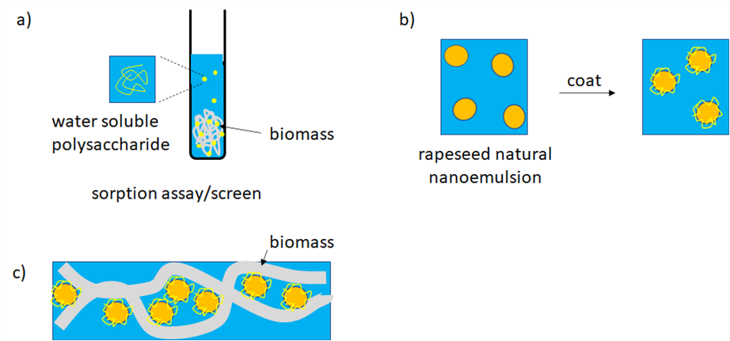

*Figure Annex-1: Project approach.*

*a ) Partition assay/screening to determine sorption of water-soluble polysaccharides into biomass as a function of polysaccharide type and sorption conditions (time, pH, salt,...)*

*b) Coating of rapeseed natural nano-emulsions (oil bodies) with water soluble polysaccharides selected from screening*

*c) Polysaccharide coating facilitates sorption of nano-emulsion droplets into biomass and ensures homogeneous distribution.*

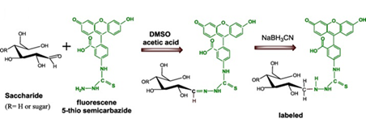

*Figure Annex-2: Example of a reaction performed to couple a fluorophore with soluble monosaccharides and polysaccharides.*

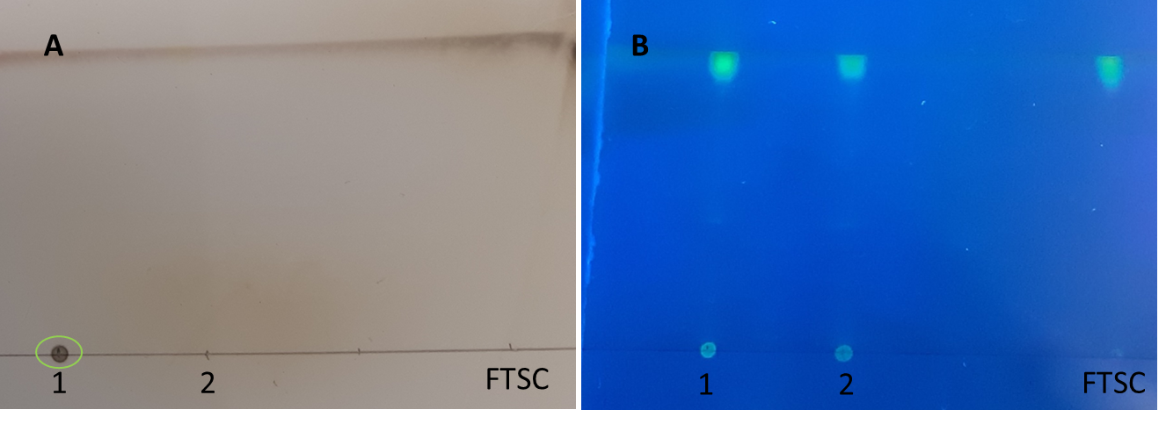

*Figure Annex-3: Example of fluorophore -coupling with carbohydrates. Panel A shows after acid hydrolysis the presence of carbohydrates (green encircled). Panel B shows the fluorescence signal at 365 nm. Incubation mixture was dialysed and lane 1 shows the retentate and lane 2 the filtrate. FTSC is the fluorophore.*

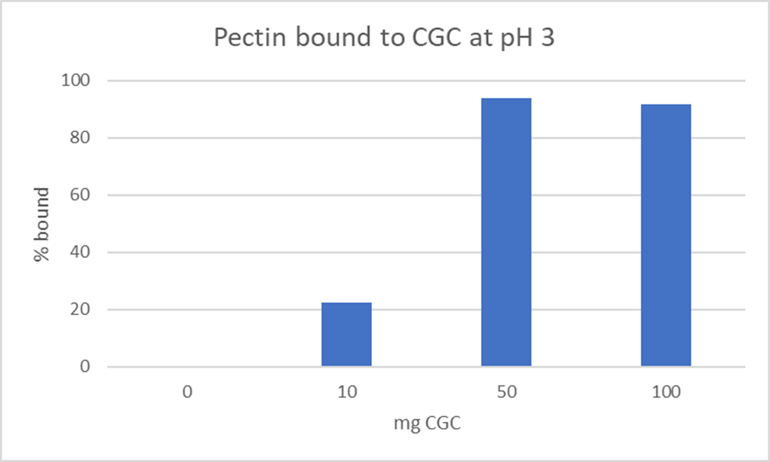

*Figure Annex-3: Example of water-soluble polysaccharides bound to chitin-glucan-complex (model for mycelium).*