**How to fill in the Staff Mobility Agreement for Teaching- 2024-2025**

Fill in page 1 with all your information typed with the computer. Fill the fields highlighted in green:

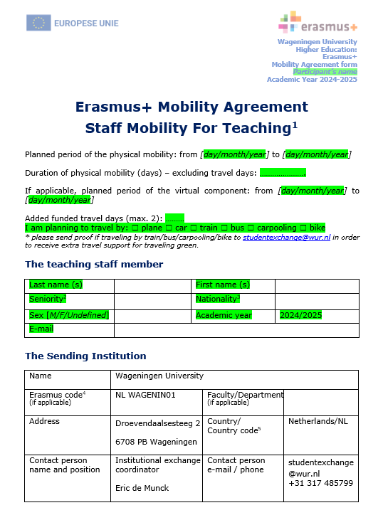

On page 2, fill in the receiving institution information:

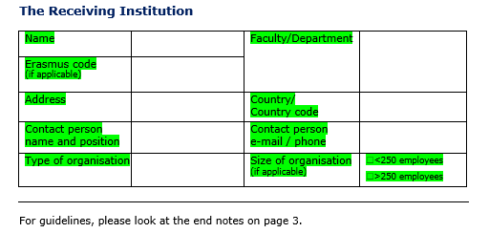

On page 3, complete the highlighted text in green:

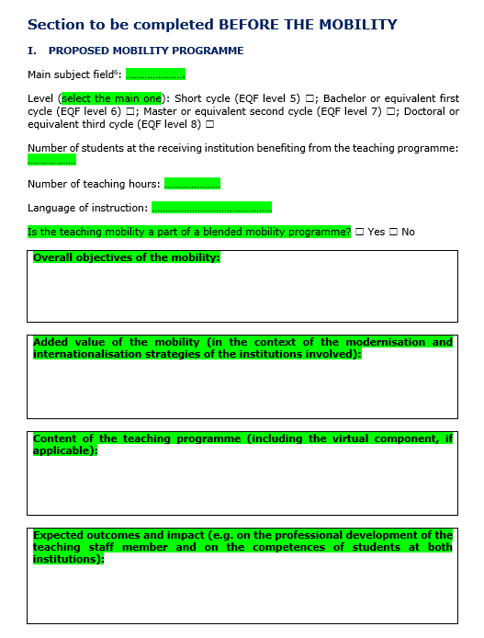

On page 4 the highlighted text in green is filled in by the staff exchange participant.

The highlighted text in yellow will be filled in by the supervisor/team leader of the sending institution and the light blue leave by the receiving institution:

***Note: All signatures have to be done either with a pen or with a digital signature.***

