**How to fill in the Grant Agreement for Staff exchange (training or teaching) 2024-2025**

Everything highlighted in green needs to be fill in by the participant.

Fill in page 1:

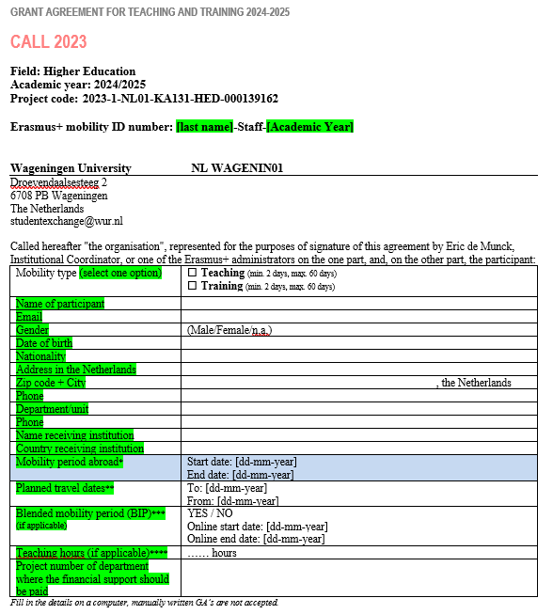

Page 2 and 3, leave the highlighted text in yellow blank, Exchange Office will fill it for you.

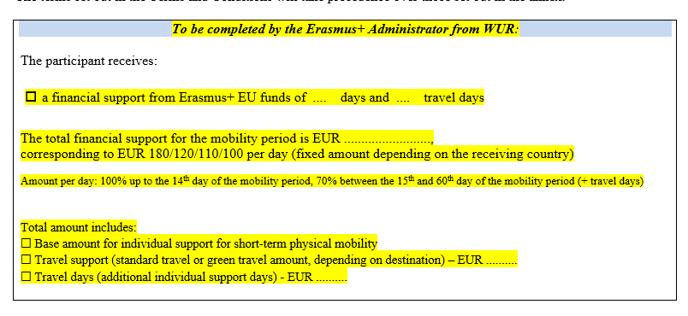

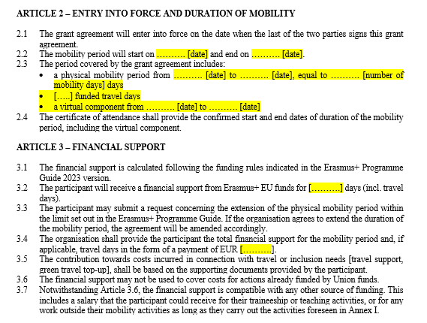

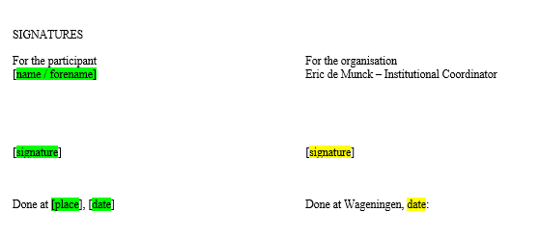On page 6, fill in the green part, exchange office will fill in the yellow part:

