Fields of GRS research  (2 options possible)  Link GRS research site |  | Sensing & measuring
 |  | Modelling & visualisation
 |  | Integrated Land Monitoring
 |  | Human – space interaction
 |  | Empowering & engaging communities
Contact person(s) | Frida Ruiz Mendoza  Jiayan Zhao  Perry den Brok (ELS)  Alexander Klippel
Thesis code and supervision | MGI-80336  Co-supervision by MGI and ELS chairgroup

Title | Facilitating Spatial Thinking through eXtended Realities
Picture  (490 x 330 minimum) | 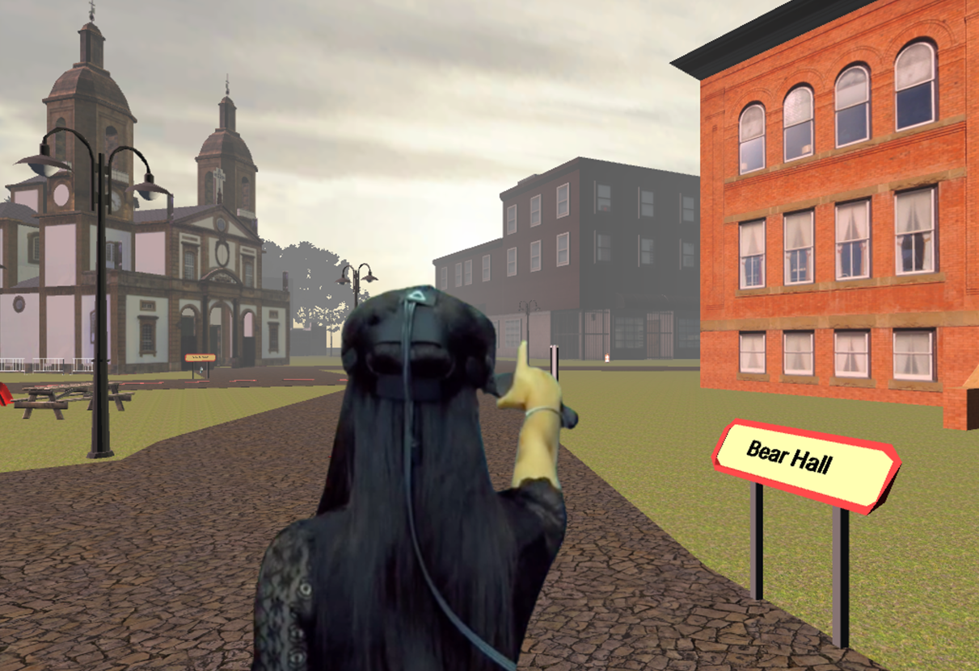
Information: intro | Al Gore famously said that 80% of all data is spatial and the abundance of spatial data currently available is adding to the excitement of being a spatial data scientist. There seem to be endless possibilities provided by new technologies to analyze, visualize, and communicate spatial data.  An essential trademark of (geo)spatial scientists is though to not only understand spatial data processing but also knowledge about what is special about spatial data and analysis and to understand concepts relevant to (geo)spatial data science. We often use the term spatial thinking for this aspect and define it as the set of competencies that allow for understanding the world around us using visualizations and analyses to identify the relations of objects and processes. Ingredients of spatial thinking are often built on primitive relations such as location, distance, direction, shape or pattern, and then lead to more complex relationships.  Strong spatial skills predict interest and success in the geospatial science disciplines. However, spatial reasoning can be a demanding process and is intertwined with individual differences; that is, some people are good at thinking spatially while others struggle. In this project we are exploring the opportunities that arise through immersive technologies, eXtended Realities (XR), such as virtual and augmented reality to facilitate and support spatial thinking. The goal is to incorporate both cognitive and (geo)spatial concepts into the creation of XR environments as skill development tools for people with difficulty in thinking and reasoning about space.
Information: background | Immersive technologies such as augmented and virtual reality, are entering a new era. Thanks to substantial investments by leading companies (e.g., Facebook(™), Microsoft(™), and Google(™)) catapulting immersive media into the mainstream, that is, they are affordable and seldom cause cybersickness anymore. At the same time, the creation and the design of immersive experiences are getting easier and easier and accessible to many more people. Tools such as Unity(™) or Unreal(™), that is, game engines, are sophisticated and well-supported development environments.  These developments open opportunities for research at the forefront of rethinking approaches to spatial thinking and how we teach it.
Relevance to research/projects at GRS or other groups (optional) | This project is part of an OneWageningen initiative as a collaboration between GRS and Education and Learning Sciences. The project is additionally supported by a university-wide research effort (WANDER) seeking to establish immersive technologies firmly in the portfolio of research and education tools for environmental and societal challenges.
Objectives
- Design creative interventions for facilitating spatial thinking through immersive media (eXtended realities).
- Evaluate interventions and assess their effectiveness
- Use virtual or real environments for assessment of immersive interventions
Literature
- Wakabayashi, Yoshiki; Ishikawa, Toru (2011): Spatial thinking in geographic information science: a review of past studies and prospects for the future. International Conference: Spatial Thinking and Geographic Information Sciences 2011. In Procedia - Social and Behavioral Sciences 21, pp. 304–313. DOI: 10.1016/j.sbspro.2011.07.031.
- Newcombe, Nora S.; Shipley, Thomas F. (2015): Thinking About Spatial Thinking: New Typology, New Assessments. In John S. Gero (Ed.): Studying visual and spatial reasoning for design creativity. Dordrecht: Springer, pp. 179–192.
- Uttal, David H.; Meadow, Nathaniel G.; Tipton, Elizabeth; Hand, Linda L.; Alden, Alison R.; Warren, Christopher; Newcombe, Nora S. (2013): The malleability of spatial skills. A meta-analysis of training studies. In Psychological Bulletin 139 (2), pp. 352–402. DOI: 10.1037/a0028446.
Requirements (optional)
- An interest in technologies and gaming
- Interest in working with immersive technologies
- Interest in empirical studies and evaluations

