Group: Organic Chemistry (ORC), Wageningen Food Safety Research (WFSR)
Project: Determine where cyanobacterial toxins accumulate in irrigated crops
Supervisors: Laura Righetti (ORC), Els Faassen (WFSR)

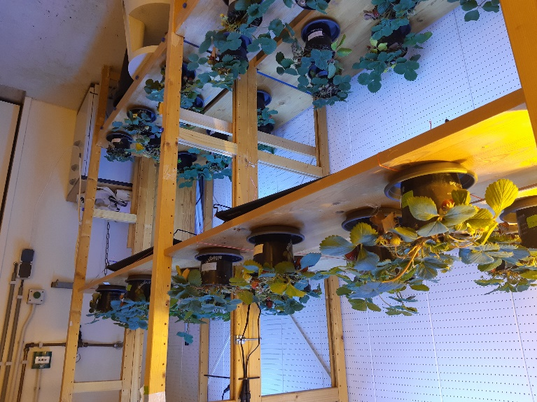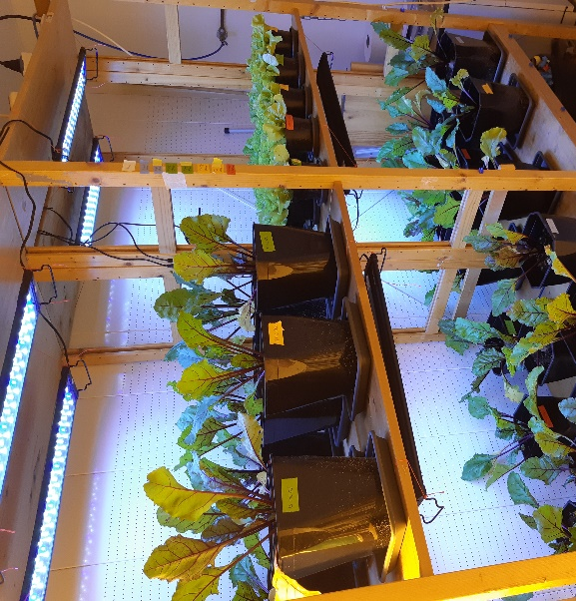

Background and research interests – Cyanobacteria (blue-green algae) can be very abundant during hot, dry summers in freshwater lakes and canals. As cyanobacteria can produce potent toxins, swimming is discouraged in cyanobacterial lakes. However, the problems are more widespread. When crops are irrigated with cyanobacteria infested water, the toxins might accumulate and end up in our food. We therefore exposed strawberries, beetroot and lettuce and studied toxin accumulation in the edible parts of these crops. However, very few toxins were detected. The main question now is whether these toxins accumulated in non-edible parts, or accumulated in so-far undetected forms in the edible parts, thereby still forming a possible health risk.

Objectives
The aim of the study is to investigate the distribution of the free and bounded toxins in the different plant organs.

Methodology / what students can learn
The plant material will be analyzed using liquid chromatography couple to high resolution mass spectrometry with the aim to quantify the free toxins. To investigate whether also the bound forms are accumulated in the plant tissue, staining protocols will be applied.

Requirements
We are looking for MSc students interested in learning advanced analytical techniques and gather basic knowledge about food safety. The project will have a duration of 6 months.

Contact information
Laura Righetti, Organic Chemistry, Agrotechnology and Food Sciences - laura.righetti@wur.nl
Els Faassen, Wageningen Food Safety Research – els.faassen@wur.nl

