 | 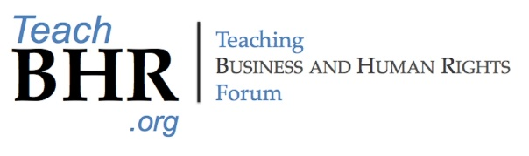

CALL FOR CONTRIBUTIONS

2024 Annual Conference, Sept. 12-13, 2024
Wageningen University in Wageningen, The Netherlands

The 2024 Annual Conference of the Global Business and Human Rights Scholars Association and of the Teaching Business and Human Rights Forum will be hosted by the Law Group at Wageningen University on 12-13 September 2024, in Wageningen, The Netherlands.
We invite contributions that reflect the interdisciplinary character of business and human rights (BHR) in theory and in practice from all disciplines. Contributions may have a research focus, a teaching focus, or both.
Format of contributions
Please submit an abstract of no more than 250 words and with five keywords; include your name, affiliation, contact information, and academic qualifications (max 5 lines) in footnote.
Abstracts may be submitted in English, Spanish, French, Arabic and Russian. If sufficient proposals are made, a panel in the relevant language to discuss full papers may be organized. The working language for common sessions will be English.
Submissions deadline
The deadline for submission of abstracts is 1 March 2024. Applicants of selected submissions will be notified by 31 March 2024. Full papers must be submitted by 1 July 2024.
How to submit
All submission information should be included in one email to 2024BHRConference@gmail.com with the email subject line “2024 BHR Proposal."
Efforts are being made to support scholars from outside the Global North who do not have funding to present at the Conference. Please include this information with your abstract if you would like to apply to be considered for funding. Any scholarship applications will be addressed separately from the paper application process.
You can join the GBHRSA for free here and the Teaching BHR Forum here.

