Building WUR-WU Database on new biobased materials to facilitate LCA analysis.

  - Final wildcard project report

WFBR: Lesly Garcia-Chavez, Marieke Brouwer, Iris Vural Gursel
WU: Ellen Slegers

24/12/2022

This project has been funded by the investment theme Transformative Bioeconomies: Towards a materials transition that phases out fossil feedstock

1. A short accessible document (max. 600 words)

Innovative idea and objective
Life cycle assessment (LCA) is the recognised method for assessing the environmental impacts of product systems. One of the essential elements of LCA is to gather reliable inventory data, representing commercial production practices. However, for novel biobased products this data is most of the time very limited or not available at all in life cycle analysis software (e.g. Simapro) and its databases (e.g. Ecoinvent). Therefore, a methodology to facilitate prospective LCA of products and processing with low technological readiness levels is needed, as well as guidance for data collection for novel commercial products.

This project has as main objectives:
- establish a common, structured approach to guide data collection and reporting
- start building a life cycle inventory database for new biobased processes and biobased materials.

Relevance to the materials transition in textiles and/or building materials?

In the bioeconomy transition we are striving for sustainable alternative biobased feedstocks for a variety of applications. Environmental sustainability is key for these alternatives. Within WFBR and WU, though various projects, both teams can have access to basic primary data on e.g. novel feedstocks, processing and conceptual process design and together form the basis for performing life cycle inventory analysis for the biobased materials transition.

What did you do?

- Project start up to first align the different team members’ expectations.
- Literature review was done to gather the latest insights on data collection standards, templates, prospective LCA and scaling up methods.
- A draft decision tree and data collection template were built to support the data collection process
- Temporary research assistant was hired to support our data collection and test the decision tree and data collection template.
- We selected 2 study cases: Miscanthus for the production of biobased insulation mats for housing and viscose and lyocell production for textile applications. These study cases were used to reflect on the developed decision tree, to improve our data collection template, and to start building a database for biobased materials.
- Seven working sessions in which we reviewed, discussed and worked on the following topics: Bibliography review on different methodologies, approaches for data collection reported by ISO, PEF, and other current standards and data accuracy. During these meetings the decisions tree and collection templates have been improved and other supporting schemes have been made to support the data collection process.
- Review on Life Cycle Inventory (LCI) formats, bottlenecks on data quality, info on scale up according to International and European standards Life Cycle Analysis (ISO, PEF), Prospective LCA, other initiatives on reporting LCI data.
- As a result we created the following schemes: a data collection decision tree, a template for data collection and a general overview of relevant aspects to consider for biobased raw materials.

Main result, achievement and highlight

Key content-wise results
We developed a general methodology for collecting existing data, generating new data, and adjusting data to represent industrial scale production, all serving as input for life cycle impact calculations. We created schemes to support the data collection process and a data collection template to support the documentation requirements. This data collection template enables the results to be traced back through the calculations to the collected basic data and process operating conditions.

To support users, we created a decision tree for data collection which is a basis for reasoning, discussion, or calculation of data. Besides, we made several support schemes to support the data collection process, in particular a general overview of relevant aspects to consider in the data collection process of biobased raw materials.

Highlights from the collaboration
By discussing the expectations openly, it was easier for each team member to contribute to the project effectively. The working sessions were valuable and provided the opportunity to get used to the different ways of thinking and working. We had a positive experience working together and we have certainty that being flexible and open to new ideas will pay off in setting future projects.

Key message
Formalized data collection activities should be established, adapted to specific circumstances (location, time frame, technology level, production scale), and reviewed periodically as a part of implementing good practice. In most cases generating new source data will be limited by the resources available and it is important to report the quality of the data that is being used, as well as the level of maturity or technological readiness.

Visual abstract
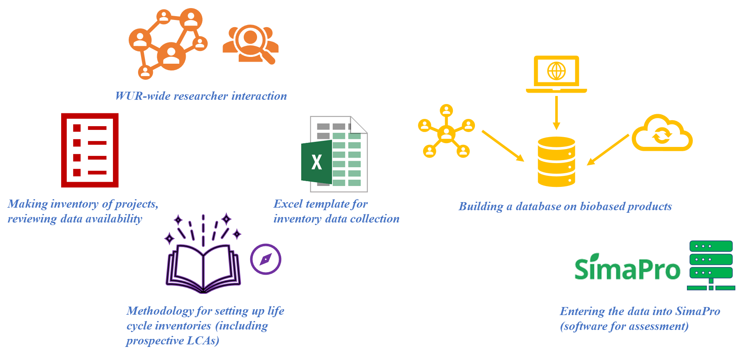

Figure 1: Key activities of project Building WUR-WU Database on new biobased materials to facilitate LCA analysis

2. Questions about ‘readiness’ and possible follow-up (max 200 word)

Where you started
We started from zero to create common understanding, way of working and language between the team members. Content-wise, we were using knowledge that was created individually from previous projects as starting point. We each had our own data files and some insight in prospective LCA development. This was the first time that we collaborated.

Where are you now

Within this project we made the following progress:
- Got Insight in various ways of working, preferences, differences and common grounds
- Overview of state-of-the-art of 1) life cycle inventory, 2) prospective LCA with specific focus on upscaling
- Developed a decision tree for data collection on processes
- Identified relevant issues to consider in the data collection for the feedstocks for the biobased material transition
- Common template for data collection and reporting
- Initial, incomplete 2 datasets for miscanthus-based isolation material and wood-based lyocell and viscose production

Remains to be done
- Build a WUR-wide database for inventory data for biobased building materials and textile applications

Potential and next steps
Biomass plays a fundamental role in decarbonization strategies that seek to mitigate the short and long-term effects of climate change. For biobased materials various biobased and renewable feedstocks are applicable. Therefore, it is important to identify and consider some critical aspects that can affect the environmental sustainability of these feedstocks.
LCA results are therefore essential to supports the material transition to renewable materials. A logical next step would be to further develop the case-studies and to add other cases with which we could fill the WUR-wide LCA database of novel renewable/biobased materials.

Innovation readiness
The project has resulted in a excel template, decision tree and other schemes to support LCA data collection. These tools have been tested in two cases (miscanthus and viscose/lyocell). Therefore, the project has a readiness score of 5 (Table 1). The next step would be to further apply the tool in more cases and roll out the tool at a WUR-level (score 6).

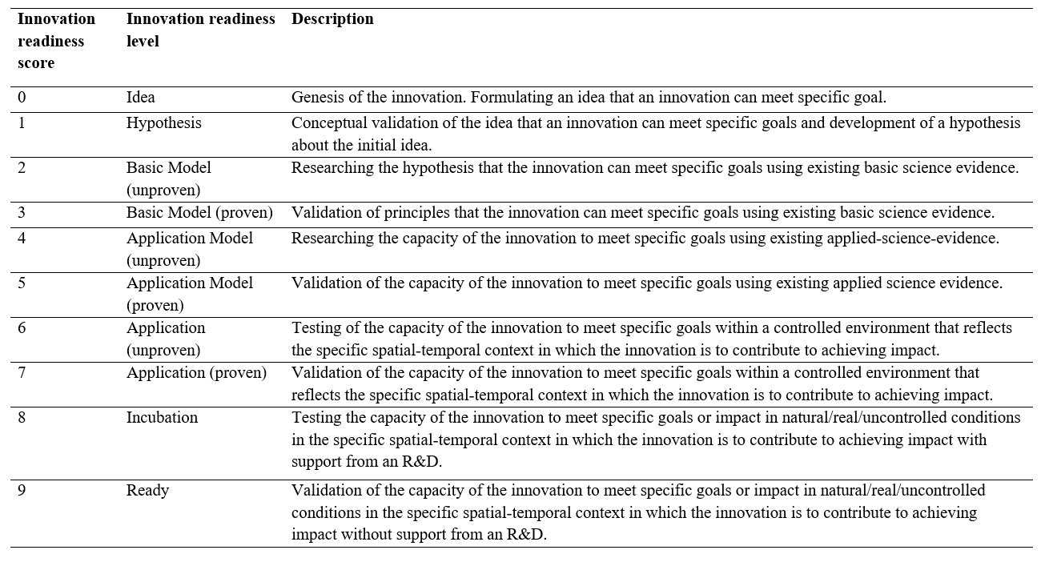
Table 1: Innovation readiness levels as distinguished by Sartas et al, 2020.

3. Learning Journey (max 300 words)

1. Did your Wildcard project involve new collaboration with disciplines or people? If so, briefly explain what was new.
This wild card project was an opportunity to start a collaboration between WFBR and WU-ORL researchers which have a common interest on LCA of bio-based products (textiles, building materials, plastics). This collaboration aimed to create new ways of collaboration amongst the members of the team, integrate common knowledge, increase networking and increasing retention on data concerning biobased products.

We started our project with a Project Start Up to create commitment in the team and allow team members to review and create consensus and ownership on the project’s goals. In order to have a general overview of the current way we are individually working, each researcher provided a summary how are we doing the data collection (sharing our approach, templates) for the different type of analysis. This was the started point to identify good practices, areas of improvement and to open a discussion towards a new common WUR methodology for data collection, which was extended during seven working sessions. We also started an inventory of LCA experts at WU-WR.

2. If applicable, did the new collaboration alter your original thinking about the topic? Did it change research directions or courses of action? If so, briefly characterize how.
No

3. Did interactions during community days and/or meetings organized by the investment theme alter your original thinking about the topic? Did such interactions change research directions or courses of action? If so, briefly characterize how.

The interaction with other projects during the community days corroborated the importance of the work we are developing in this wildcard. Some examples from other wildcards in this program for which a LCA will be valuable are: use pineapple leaves for high quality fiber and other biobased applications, use of seaweed for renewable building materials, developing new dyes and additives for fossil-free textile chains, used of microalgae as SLA 3D printing material.

4. Did you meet any challenges during implementation of your wildcard project? If so, what kind of challenges where these?
In the case of new biobased materials, the main challenge is often how to generate new data for the product and process because representative data do not exist or cannot be estimated from existing sources. Generation of new data takes time and required close contact with people with appropriate expertise (e.g., competent organizations or researcher using appropriate and censused estimations and assumptions). Lack of clear and high-quality data for the selected processes was a challenge. We still need to have more time to contact experts on the selected cases to discuss the specific data issues.

5. If applicable, how were these challenges eventually addressed? Did activities organized by the investment theme contribute to overcoming challenges? If so, briefly indicate how.
We would like to address the challenges mentioned in previous questions in a follow-up project in which we will focus on the verification and detailed analysis of data collected for the 2 selected biobased materials, extend the database for other novel biobased materials and to get in touch with experts to get a recommendation and judgment on the quality of the collected data.

6. Has your involvement in the investment theme resulted in any new initiatives or spin-offs that would probably not have emerged if you had not participated? If so, briefly indicate how these new initiatives came about.
We want to continue with this initiative by refining this methodology and share it with other parties interested.

4. Additional project specific deliverables
Copy-paste the deliverables provided in your submission document and explain how you have met these deliverables. If deliverables could not be reached, please explain.

Deliverables
- Short accessible document that describes the methodological innovation project and its rationale Reported in section 1 of this document.
- Presentation at a community meeting of the investment theme. Done
- Report of the results of the learning journey that describes the key lessons learned about the methodological innovation. Reported in section 3 of this document ‘Learning Journey’.
- Excel template for data collection with guidelines for setting up life cycle inventory. Reported in the Annexes section of this report.
- Database (filled excel template) for the 3-5 selected novel biobased materials. Reported in the Annexes section of this report.

Links to or copies of deliverables
Please provide links to or copies of deliverables below. You may insert them as Annexes in this document.
Deliverable inserted in the Annexes.

Annex. Results: Excel template for data collection with guidelines for setting up life cycle inventory.

Introduction
Life cycle assessment (LCA) is a standardized method for assessing the environmental impacts of product systems along the life cycle. An LCA study consists of four main phases:
Phase 1: Defining the goal and scope of the study.
Phase 2: Making a model of the product life cycle with all the environmental inputs and outputs. This data collection effort is usually referred to as life cycle inventory (LCI).
Phase 3: Understanding the environmental relevance of all the inputs and outputs. This is referred to as life cycle impact assessment (LCIA).
Phase 4: The interpretation of the study.

One of the main challenges for performing LCA studies is phase 2 in gathering reliable inventory data representing industrial production practices. For novel biobased products and their processing chains this data is most of the time very limited or not available at all in life cycle analysis software (e.g. Simapro) and its databases (e.g. Ecoinvent). So-called life cycle inventory data forms the backbone of every LCA study. This refers to the energy and raw material requirements and emissions associated with biobased product systems. Therefore, a method to facilitate carrying out LCA of biobased products and processing with low technological readiness levels is needed, as well as guidance for data collection for commercial products with unknown environmental performance.

The objective of this report is to establish a common, structured approach on how data should be collected and reported for new biobased processes and biobased materials to be used in LCA studies.

This report provides guidance on choice of data estimation method considering the technology readiness level, availability of data and resources (e.g., simulation software) where there is a trade-off between data availability and accuracy or representativeness of the actual process (Chapter 2). A decision tree was developed to support the data collection process, with specific focus on the type of process i.e., chemical, biochemical or mechanical (Chapter 3)) and for modelling biological feedstocks (Chapter 4). As an additional output from this project an Excel template for inventory data collection and recording is prepared (Chapter 5). This template is used in 2 case studies to start building a database of relevant biobased materials which are not available in standard databases (Chapter 6)​. One of the case study is linked to the textile domain: Lyocell fibers and the other is linked to the building domain: Miscanthus insulation materials.

Data estimation methods for Life cycle inventory
It is useful to distinguish between two types of data:
1. Foreground data, which refers to specific data you need to acquire for modeling your system. Typically, it is data that describes a particular product system or a specialized production system.
2. Background data, which is data for the production of generic materials, energy, transport and waste management. This data you can find in SimaPro databases and from literature.

In many cases foreground data needs to be collected from specific companies or from research working on new product development. Collecting data from other parties is not always easy. Most frequently, questionnaires need to be made to collect such data. It is important to establish good contacts with the people who are asked to fill in the questionnaire and to understand what these people know, in what way data is available, and have clarity on the terminology and units that are used. Confidentiality issues can hinder the data collection.

For novel products or processes, such as biobased materials, usually the collected data does not represent commercial or industrial scale production. In general, for prospective LCAs the challenge is to determine the future development of the technology or product (Hetherington et al 2014; van der Giesen 2020) based on limited early stage research data (Becker et al 2020) and to deal with the novel (and/or unclear) product function/service e.g. functional equivalence (van der Geisen et al 2020, Cucurachi et al 2018). In this project we have focussed on the first challenge. The data collection approaches can be separated in three main ways:
Primary data: company data, expert interviews, scientific articles, patents, unpublished results
Secondary or proxy data, usually with certain assumptions
Calculations: varying from mass and energy balances to simulations of process equipment including scale up calculations

Next to the issue of data availability, data quality is also a problem. Thonemann et al. (2020) described multiple criteria for data quality of which two are discussed due to relevancy on for the decision support tool, i.e., reliability and temporal correlation. The reliability of data can be improved by being transparent on all available data, also indicated by Villares et al. (2017) who stated that “reporting of iterative LCAs generated as new processes are developed is encouraged” (p. 1619).

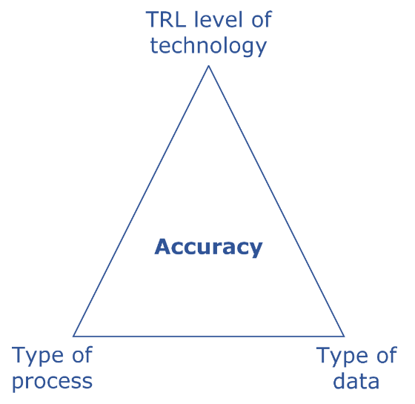
Figure 2: Accuracy influence triangle.
The resulting accuracy of the LCA results is influenced by 1) the type of data used in combination with the data collection procedure, 2) the type of process it concerns (e.g. biochemical or mechanical) and 3) the technological readiness level of the raw data set. Figure 2 illustrates this accuracy triangle. One always needs to find a balance between the accuracy and representativeness of the upscaled data and the effort one need to do.

3. Decision Tree
The following decision tree (see Figure 3) was developed to support the data collection process, with specific focus on the type of process (i.e., chemical, biochemical or mechanical) and to have a simple visualization of the most common sources of data. Data collection includes finding, processing, and improving existing data as well as generating new data by surveys, questionaries, or measurements, or new estimates.

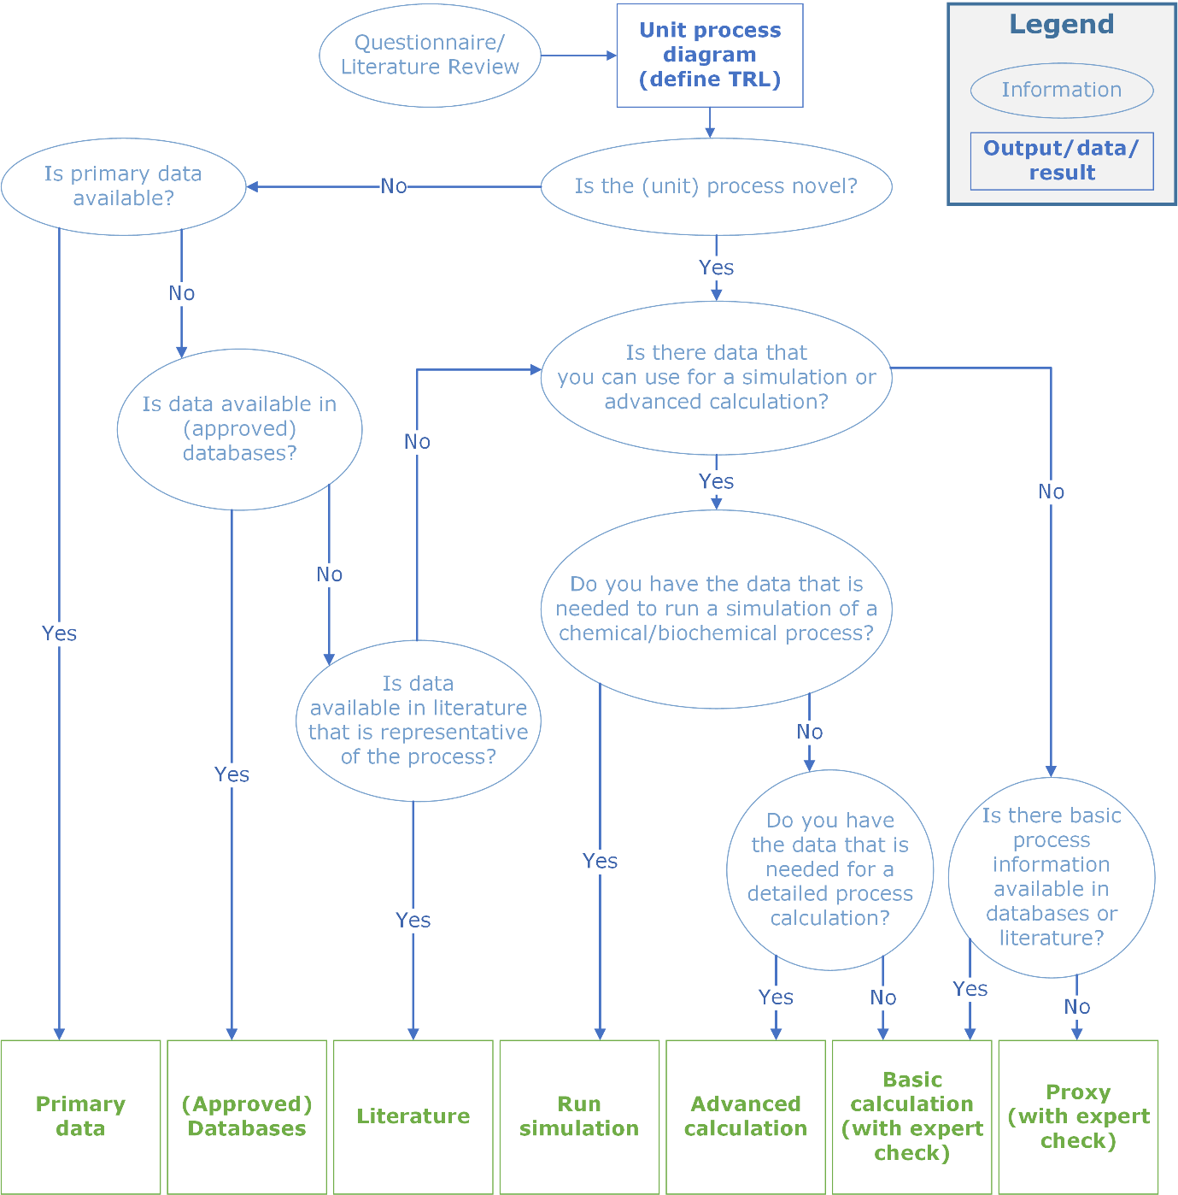
Figure 3.Decision tree for data collection per unit process.

Based on our own experience we see that for a novel process or product, basic data is mainly obtained via process simulations, basic or advanced calculations. This commonly also results in generation of new data in case of data gaps, using proxy or surrogate data to fill the gaps. In all cases we advise to look for expert judgments to perform quick data quality and control (QC) checks. The common options in terms of basic calculations, advanced process calculations and simulation tools are visualized in Figure 4, for chemical, biological and mechanical processes.

The choice of the most suitable and recommendable data estimation method depends on the technology readiness level, availability of data and resources (e.g., simulation software). In here there is a trade-off between data availability and accuracy or representativeness of the actual process (Chapter 2). In addition, one should realise that process simulation and process calculations each require a high degree of knowledge of process design, simulation software use, and technological expertise.
It is our recommendation to build upon and extend as far as possible on existing data rather than initiating new collection.

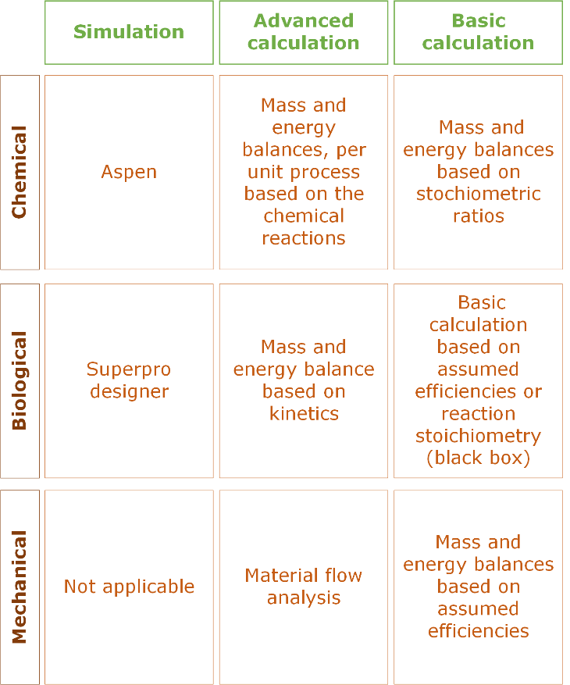
Figure 4. Calculation and simulation options

4. Guidance for biological feedstock data
Biomass plays a fundamental role in decarbonization strategies that seek to mitigate the short and long-term effects of climate change. For biobased materials various biobased and renewable feedstocks are applicable. Therefore, it is important to identify and consider some critical aspects that can affect the environmental sustainability of these feedstocks. The scheme in Figure 5 provides an overview of main relevant aspects that need to be considered in the analysis of these specific type of feedstocks.

Note, these relevant aspects are not exhaustive and indirect effects may occur. For example, most severe indirect effects during biomass production are related to land conversions, cultivation management practices (which requires a lot of energy). At the same time an increase in crops’ demand is a stimulus for technological development for a more efficient use of land (yield improvement), better use of co-products to try to compensate for land demand, as well as energy reduction and optimization during biomass cultivation (PBL;2012).

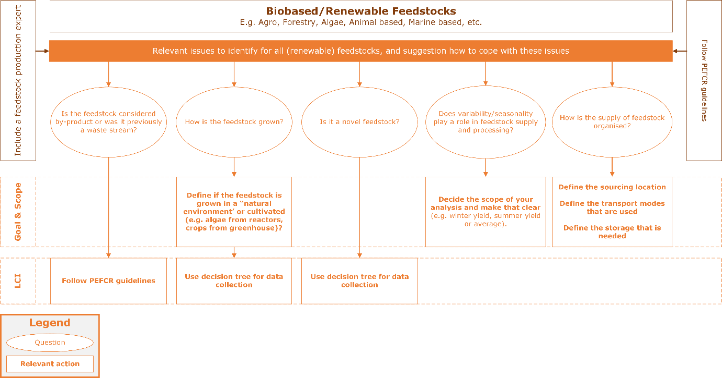
Figure 5. Relevant aspects to consider for biobased and renewable feedstocks.

5. Excel Template

The data collection template was created to serve as a basic for a future WUR-WU database on biobased products. It is still needed to create broader consensus with our institutions about the use of this format for future LCI data collection.

6. Test cases
The Excel template was used in 2 case studies to start building a database of relevant biobased materials which are not available in standard databases, which are explained below.

Miscanthus

Process description
Pre-treatment: For the miscanthus case, we assume that after the harvesting, the fibres are shredded and then broken by steam explosion. Steam explosion (SE) is a pre-treatment technique with a biomass yield between 79% to 97% (Shahrukh et al. 2015; Wolbers et al. 2018). Some of the volatile solids of the biomass are lost during steam explosion treatment due to the mechanical force of decompression. The waste stream resulting from the steam explosion process is a condensate containing organic matter (extractive compounds).

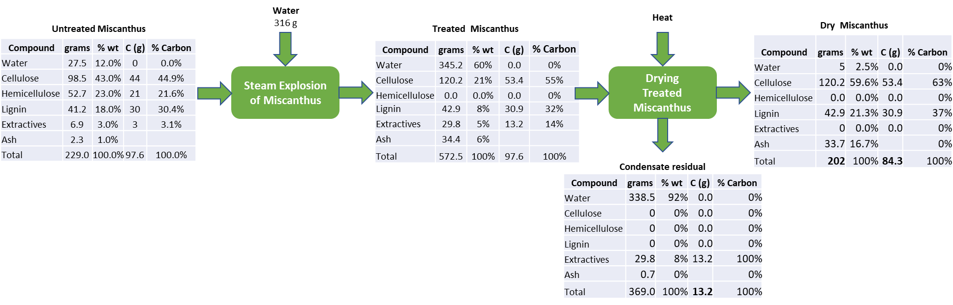

Figure 6. Mass balance diagram for the pre-treatment of Miscanthus to produce insulation panels proposed by (Menardo et al. 2013).

Molding and addition of additives: to increase the stability of the insulation material, binders are used Polypropylene is commonly used as a binder (<20%). In some cases, binder is not added, these are called binderless insulation panels. Additives like flame-retardants and fungicides are added to reduce the flammability of the material and to protect the fibres against fungal decay and vermin infestation. Borax and sodium carbonate are the flame retardants and thiocarbamate is used as fungicide. Before the addition of the additives a drying step is necessary and the ending step is the hot pressing between 180⁰C-200 ⁰C, 10-15 minutes and 12 MPa (Figure 7)

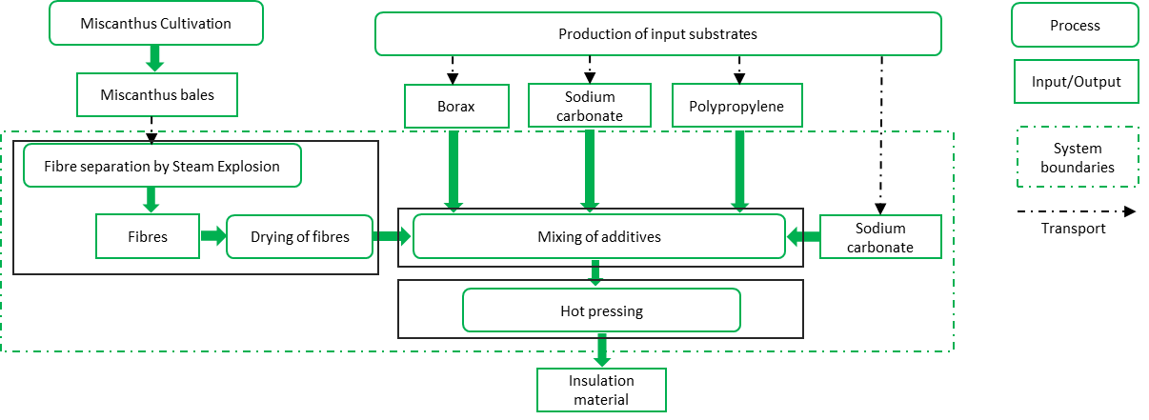
Figure 7. Process diagram for the production of Miscanthus-based insulation panels proposed by (Wagner et al. 2017)

Decision Tree
- Is the unit process novel? Yes
- Is primary data available? No, not to us
- Is data available in approved databases? No
- Is data available in literature that is representative of the process? Yes, partly in Wagner et al. 2017 and Zimbardi F. et al. 2002 (although biomass used is Straw therefore, we are using a proxy)
Upon filling in the dataset some datagaps appeared. We went back to the decision tree.
- Is there data that you can use for a simulation or advanced simulation? No
- Is there basic process information available in databases or literature? Yes, partially so done some basic calculations/assumptions.

Data collection template
The template was used to document and explain the sources for the Miscanthus case. The most important step while using this template is to use the comments field to assumptions made and to check roughly the mass balance of each unit process. Regarding the data quality field sometimes is difficult to assess but in most of the cases for process under development the quality of the data is expected to be low in comparison with well-established industrial processes. Data was collected partly collected by Wagner et al. 2017 and Zimbardi F. et al. 2002.

Lyocell

Process description
The production of Lyocell consists of the following main steps (see Figure 8).

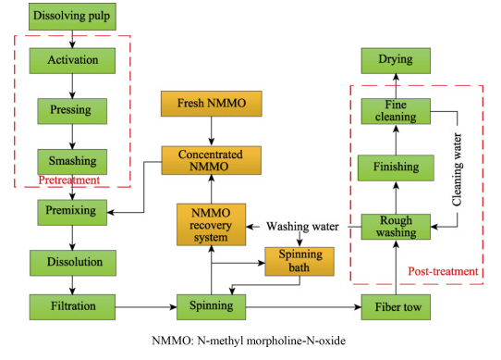
Figure 8. Process diagram for the production of Lyocell fiber (Jiang et al 2020)
First the wood pulp (feedstock) needs to be dissolved and treated to ensure that the cellulose fibers are released (Jiang et al 2020). The pretreated cellulose is then mixed with a solvent, commonly NMMO (N-methyl morpholine) (Guo et al 2021). After the mixing the cellulose will swell due to the NMMO penetration in the fibers and gradually the cellulose dissolves due to the high polarity of NMMO. After a filtration step the cellulose is spun after which the NMMO solvent can be recovered and the fibers treated further. The main differences with cellulose production are provided in Figure 8.
The main material inputs for the production process are feedstock, water, cross-linking agents for the spinning, NMMO together with NaOH and HCl for the recovery of NMMO, as well as electricity.

The largest challenge when collecting data is to get sufficiently detailed information on the water balance of the production system. The water cycle in the Lyocell process is complex and not very clear. Every paper uses a slightly different way of representing the water cycle. For instance, some say additional water input is required in a process, while others says it only uses recycled water. Furthermore, it is not clear how much water can be recycled and how much fresh water is needed. In addition, several processes require high temperatures, therefore some paper also use steam, instead of water. To make it even more complex, water (a small amount) is also mixed with the solvent. Also water is required in almost all processes and some water is also discharged to waste water (according to some articles). According to most sources, water input is required for spinning and washing. And waste water occurs during NMMO recycling and drying.
From an LCA point of view the water input in itself would probably not have a high environmental impact. But from a flow/mass balance perspective, it is.

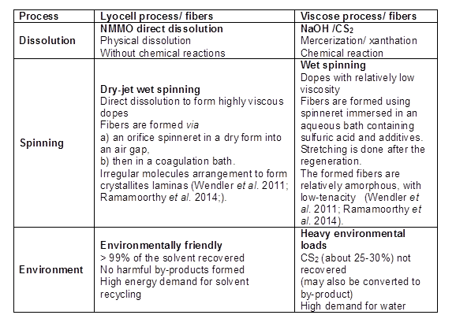
Figure 9. Descriptive comparison between Lyocell and viscose fiber production (Zhang et al 2018)

Decision Tree
- Is the unit process novel? No, although it is relatively new
- Is primary data available? No, not to us
- Is data available in approved databases? No
- Is data available in literature that is representative of the process? Yes, in Guo et al 2021 for example (although geographical scope China)
Upon filling in the dataset some datagaps appeared. We went back to the decision tree.
- Is there data that you can use for a simulation or advanced simulation? No
- Is there basic process information available in databases or literature? Yes, partially so done some basic calculations/assumptions.

Data collection template
Data was collected for the viscose production (reference situation), using Guo et al 2021 as main data source. The same source was used to collect the data for the lyocell process.

References

Becker, M.-Y., Kohlheb, N., Hunger, S., Eschrich, S., Müller, R., Aurich, A., 2020. Early-stage sustainability assessment of biotechnological processes: A case study of citric acid production. Engineering in Life Sciences 20(3-4), 90-103.

Cucurachi, S., van der Giesen, C., Guinée, J., 2018. Ex-ante LCA of Emerging Technologies. Procedia CIRP 69, 463-468.

van der Giesen, C., Cucurachi, S., Guinée, J., Kramer, G.J., Tukker, A., 2020. A critical view on the current application of LCA for new technologies and recommendations for improved practice. Journal of Cleaner Production 259, 120904.

Guo, S., Li, X., Zhao, R., & Gong, Y. (2021, 2021/08/01). Comparison of life cycle assessment between lyocell fiber and viscose fiber in China. The International Journal of Life Cycle Assessment, 26(8), 1545-1555. https://doi.org/10.1007/s11367-021-01916-y

Hetherington, A.C., Borrion, A.L., Griffiths, O.G., McManus, M.C., 2014. Use of LCA as a development tool within early research: challenges and issues across different sectors. The International Journal of Life Cycle Assessment 19(1), 130-143.

Jiang, X., Bai, Y., Chen, X., & Liu, W. (2020, 2020/02/01/). A review on raw materials, commercial production and properties of lyocell fiber. Journal of Bioresources and Bioproducts, 5(1), 16-25. https://doi.org/10.1016/j.jobab.2020.03.002

Parvatker, A. G., and Eckelman, M. J. (2019). Comparative Evaluation of Chemical Life Cycle Inventory Generation Methods and Implications for Life Cycle Assessment Results. ACS Sustainable Chemistry and Engineering, 7(1), 350–367. https://doi.org/10.1021/acssuschemeng.8b03656

Piccinno, F., Hischier, R., Seeger, S., and Som, C. (2016). From laboratory to industrial scale: a scale-up framework for chemical processes in life cycle assessment studies. Journal of Cleaner Production, 135(October), 1085–1097. https://doi.org/10.1016/j.jclepro.2016.06.164

PBL (2012), Sustainability of biomass in a bio-based economy, PBL publication number 500143001, The Hague, PBL Netherlands Environmental Assessment Agency. https://www.pbl.nl/sites/default/files/downloads/PBL-2012-Sustainability-of-biomass-in-a-BBE-500143001_0.pdf

Shahrukh, Hassan et al. 2015. “Net Energy Ratio for the Production of Steam Pretreated Biomass-Based Pellets.” Biomass and Bioenergy 80: 286–97. http://www.sciencedirect.com/science/article/pii/S0961953415300209.

Thonemann, N., Schulte, A., Maga, D., 2020. How to Conduct Prospective Life Cycle Assessment for Emerging Technologies? A Systematic Review and Methodological Guidance. Sustainability 12(3), 1192.

Tsoy, N., Steubing, B., van der Giesen, C., and Guinée, J. (2020). Upscaling methods used in ex ante life cycle assessment of emerging technologies: a review. International Journal of Life Cycle Assessment, 25(9), 1680–1692. https://doi.org/10.1007/s11367-020-01796-8

Villares, M., Işıldar, A., van der Giesen, C. et al. Does ex ante application enhance the usefulness of LCA? A case study on an emerging technology for metal recovery from e-waste. Int J Life Cycle Assess 22, 1618–1633 (2017). https://doi.org/10.1007/s11367-017-1270-6

Zhang, S., Chen, C., Duan, C., Hu, H., Li, H., Li, J., Liu, Y., Ma, X., Stavik, J., and Ni, Y. (2018). "Regenerated cellulose by the Lyocell process, a brief review of the process and properties," BioRes. 13(2). 4577-4592.

Wagner, Moritz et al. 2017. “Novel Miscanthus Germplasm-Based Value Chains: A Life Cycle Assessment.” Frontiers in Plant Science 8: 990. https://www.frontiersin.org/article/10.3389/fpls.2017.00990.

Wolbers, P. et al. 2018. Biomass Pre-Treatment for Bioenergy - the Steam Explosion Process Technology. IEA Bioenergy, Energy Technology Network.

A current area of research area that promote the integration of environmental criteria in early stages of technology development toward responsible research and innovation. https://knowledge4policy.ec.europa.eu/publication/prospective-life-cycle-assessment-emerging-technologies-bio-based-materials_en

